Name:______________________________________________________ Date: ______________

Construct a graph that represents the information presented in the table below.
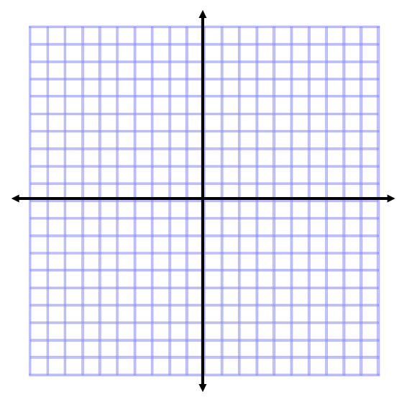

X | Y
-2 | 1
-1 | 3
0 | 5
1 | 7
2 | 9
3 | 11

1. Describe the relationship in the table and graph above.

2. Describe the rate of change in the table and graph above.

