Name:______________________________________________________ Date:_______________
Tier One
Draw a line to match the graph with the corresponding table. Answer the questions for the table-graph pair on the lines below the table.
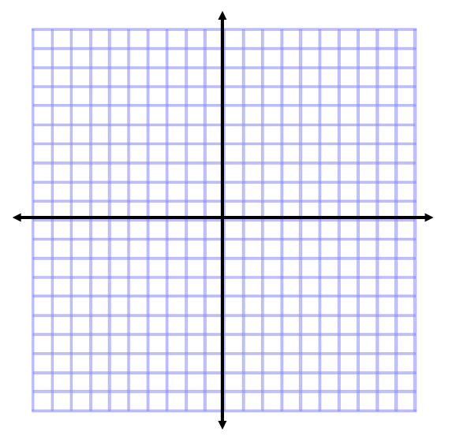

X | Y
3 | 0
4 | -1
5 | -2
X | Y
0 | 4
1 | 5
2 | 6

X | Y
-4 | 0
-1 | 2
2 | 4
X | Y
0 | 0
1 | 1
2 | 2

1. What is the rate of change?
2. What is the relationship?
3. Write one or two sentences describing a real life relationship that could be represented by the table. | Is running in a race with her older brother. She runs one mile per hour, but her brother gives her a head start by letting her start at the four mile marker.

