

5. When adding two integers with different signs, how can you tell what sign the sum will have? Why does this make sense?

3. Find the distance between -12 and 17. How can you find this answer without using a number line?

4. Insert the appropriate sign (<,>,=) to show which sum is greater.

2. Solve: -25 + 34=

Above Grade Level

6. Dale owes his sister $10. He earns $40 moving lawns. First he pays his sister the money he owes her, then, he buys two CDs for $10 each. How much money does Dale have now?

1. List as many places you can think of that negative integers are used in real life.



3.

**Use the thermometer to find the difference between -10 and 20 degrees.**

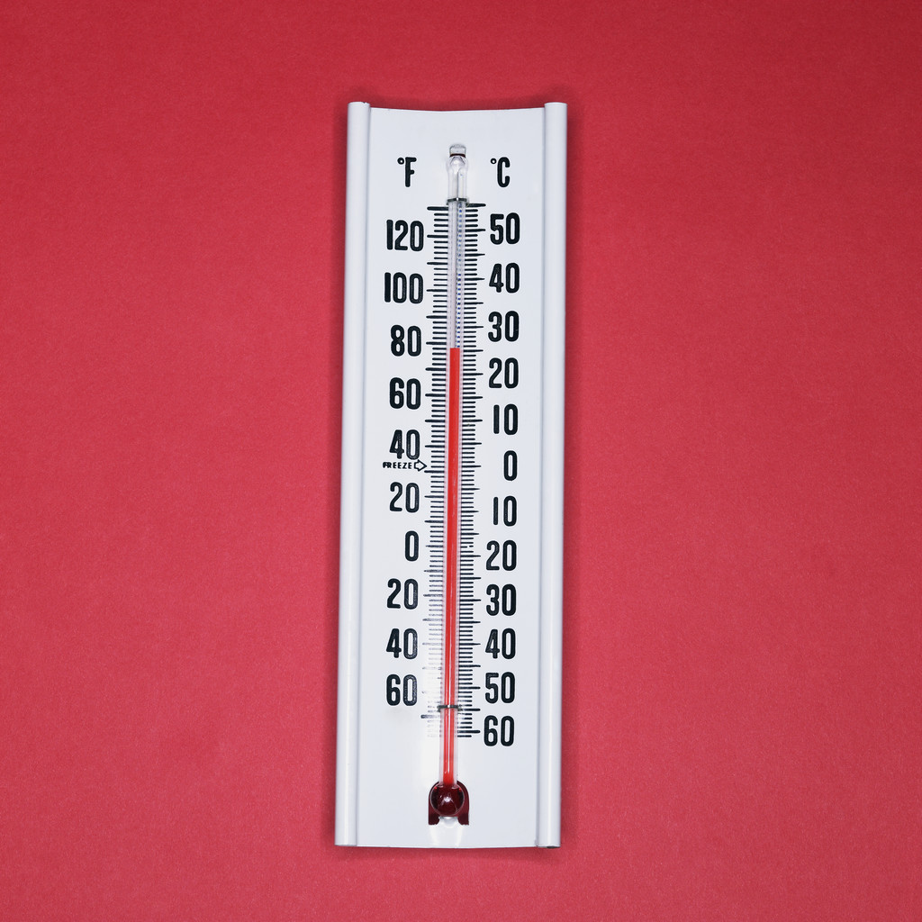

Below Grade Level

6. Dale owes his sister $15. He earns $20 mowing lawns. How much money does he have left after he pays his sister back?

5. When adding two integers with different signs, how do you know what sign the sum will have? Give an example.

4. Greg has $-7. Rachel has $0. Who has more money? How do you know?

2. Use a number line to solve the following problem. -5 + 4=

1. List as many places you can think of that negative integers are used in real life.



6. At 6 am, the temperature is -10 degrees Fahrenheit. At noon, the temperature is 12 degrees Fahrenheit. What is the overall change in temperature from 6 am to noon? Draw a picture to show your thinking.

3. Find the distance between -1 and 4. Draw a number line to show your answer.

At Grade Level

5. When adding fractions, the answer always has the same sign as the greater number. Explain why.

4. Which number is greater, -7 or 3? How do you know?

2. Solve:

1. Make a list of as many places you can think of that negative integers are used in real life.