Name: _________________________________________________________________________ Date:_____________
Choose three activities from the grid below.
Objective: Solve real-life and mathematical problems involving surface area, and volume.
Linguistic  Write a step-by-step guide for finding surface area and volume of a triangular prism. Include an example. | Bodily-Kinesthetic  Find an example of rectangular prism in the classroom. Find surface area and volume of the object. | Musical  Write a song or rhyme students could use to learn and remember surface area and volume. | Interpersonal  Create a learning game a teacher could use to teach surface area and volume.
Intrapersonal  Write a journal entry detailing what you have learned about surface area and volume. Include an example. | Naturalistic  Where in nature to we find prisms? Sketch a picture or describe a prism that might be found in nature. Provide dimensions and find surface area and volume. | Linguistic  Write a letter to a friend describing how to find surface area and volume. | Interpersonal  Work with a friend to make a handout describing how to find surface area and volume of a triangular prism. Include an example.
EVERYBODY  Give at least two examples of when you would need to find surface area in real life.  Give two examples of when you would need to find volume in real life. | Logical-mathematical  Find surface are and volume of the triangular prism.  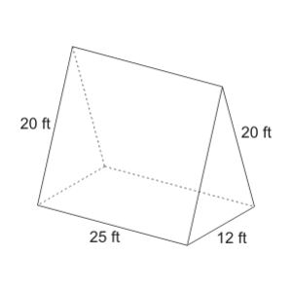 | Visual-Spatial  Draw each face of the rectangular prism. Include the dimensions of the faces.  2 cm  8 cm  3 cm | Logical-mathematical  Find surface area and volume of the rectangular prism.  6 cm  4 cm  3 cm
Visual-Spatial  Use a model of a rectangular prism to find surface area and volume. | Existential  What would the dimensions of a “perfect” rectangular prism be? Explain why the prism would be perfect, and find surface area and volume of the prism. | Bodily-Kinesthetic  Find the total surface area and volume of all of the books you have with you in class. | Intrapersonal  What is your favorite strategy to use to find surface area and volume? Describe the strategy and explain why it is your favorite.

