Name: ___________________________________________________________________ Date:______________
1. Use the pattern to complete the rest of the table.
Tier Two
X | Y
-1 | 2
0 | 4
1 | 6
2

2. Graph the information represented in the table.
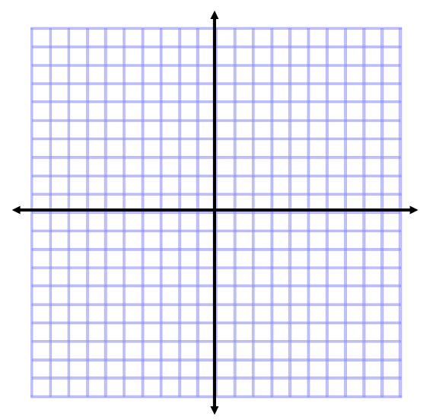

3. What is the rate of change in the table and graph?

4. What kind of a relationship is represented in the table and graph?

5. Write one or two sentences describing a real life situation that could be represented by this table and graph.

