Name: ___________________________________________________________________ Date: ______________
Tier Three

Read the situation below. Use it to construct a table and a graph to represent the relationship.
Rachel buys a summer membership to the skating rink. It costs $30 to sign up, and then $0.50 every time she goes skating.
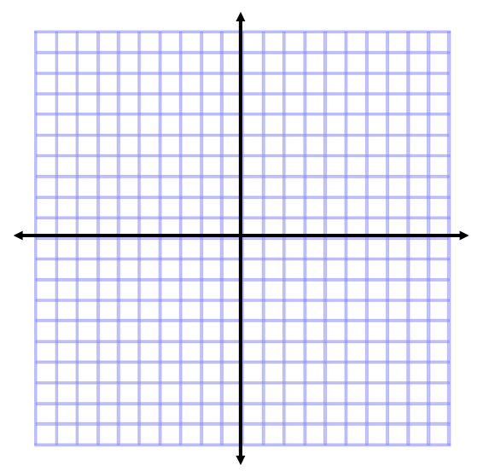

X | Y

1. Describe the rate of change.

2. What is the relationship?

3. Write a different real life situation that could also be represented by the graph and table.

